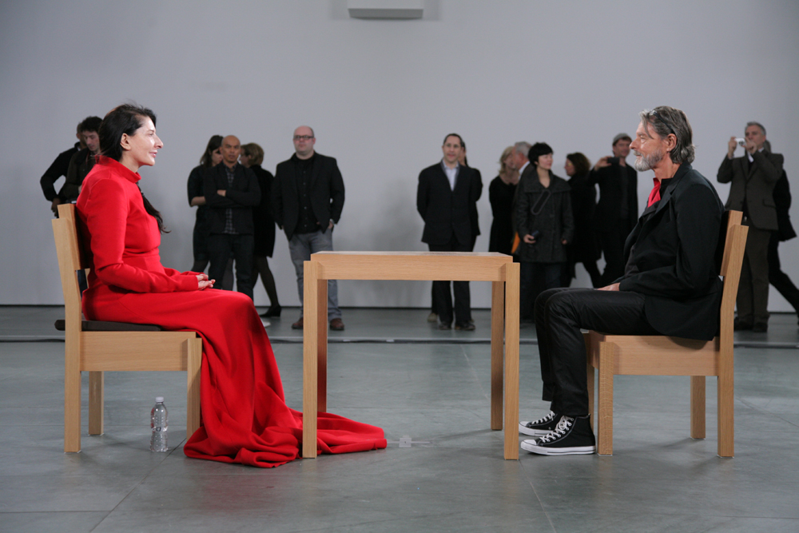
Figure 1: The Artist is Present, 2011, Marina Abramovic, MoMa

How have performance artists that are transgressive and provocative used taboos to challenge the viewer and engage audiences?

By Ross Davies

Student Number: 34220143

Word Count: 9761

Abstract
This thesis looks to discuss the development of performance art and performance artists within the world of art. Performance art began to develop and flourish within the Cabaret Voltaire under the DADA movement. What is already clear is that performance art has always contained heightened emotional responses and honesty within it, whether it is to the performer themselves or the audience. Often in the case of using taboos, which are either provocative and/or transgressive in nature. These styles of performance allow the performer and the viewer to enter a higher level of honesty, emotion and engagement in the work because; opinions and emotions are developed. A work of art that is testing and challenging for the artist and their boundaries that subsequently challenge the viewer. This could be the artist deliberately wanting to provoke or encourage an opinion or emotion from the audience to inspire change of some form. I will be directly looking at artists that have engaged audiences in this way including Marina Abramovic, Tania Burguuera, Carolee Schneemann, and Despina Zacharopoulou. It’s important to understand performance and the different styles of performance that have developed in the movement and throughout its history so I will also be providing a background to the different categories of performance, which will give further context to these case studies. Looking at how a performance artist can engage the audience through these different techniques of the artist performing as an individual, that artwork becoming a social community piece of active engagement and the artist becoming the artwork in social sculpture. Through doing this we should be able to form a conclusive understanding into the level of engagement developed through the use of provocative and transgressive concepts and actions.

Acknowledgements

Special thanks to:

- Charlie Gere, Course convener and senior lecturer of the History and philosophy of the arts at Lancaster University

- Jen Southern senior lecturer of Fine Art and New Media at Lancaster University

- All the Fine Art Lecturing staff and students at Lancaster University

Table of contents

- Introduction…………………………………………………………………………………………………………6

2a) Defining what is provocative and transgressive within art
2b) Defining what performance art is

- History and Litrature review of transgression and provocation within performance art…………………………………………………………………………………………………………………………9

3a) The origins of performance and its emergence in Germany
3b) Provocation and Transgressions development and impact on the world of art – in particular reference to the 1970’s.

- Catagories of performance; the object, the individual, and the influence that has audience participation……………………………………………………………………………………..…18

4a) The Individual; Risk, Vulnerability and Emotion
4b) The Social;
4c) The Object;

- Case Study: Marnina Abramovic the provocative and transgressive? …………………23

5a) Provocation within her performance practice of the 1970’s
5b) The progression of performance to her practice to date

- Case Study: Carolee Sheenmann the provocative and transgressive?................... 26

6a) The use of provocation and transgression to dicuss the perception of the feminine and the female form in art and society

- Case Study: Tania Bruguera the provocative? ……………………………………………………30

7a) The use of provocation within performance as a means of raising and debating political situations
7b) Defining ‘behavior art’ and its impact on the provocation in performance.

- Case Study: Despina Zacharopoulou the new?......................................................33

8a) Performance art today and engaging audineces in the 21st century
8b) Transgressional performance and the viewer

- Conclusion …………………………………………………………………………………………………………36

How have performance artists that are transgresive and/or provocative used taboos to challenge the viewer and engage audiences.

Introduction

Performance art is an art practice that has only been developed and considered a credible art medium in the last century. Seeing pioneering artists in performance, shock the art world, which seemed to be intentionally provocative or transgressive. These works often involved body mutilation, nudity and the body being manipulated in a provocative context or placing an artwork in a completely new context and environment. In this report my intention is to provide a comprehensive literature and history review of performance art, define what it means to be provocative and transgressive, and explore artists use of taboos within performance and what that represented. First, defining what these words mean and the question that I am wanting to debate and answer. A taboo is a concept that has become key within art since the 20th century and is especially prominent within performance art. This is primarily through the concept or action to a performance. Often defined through “a social or religious custom prohibiting or restricting a particular practice or forbidding association with a particular person, place, or thing” (Fowler, 2012). Meaning the work deliberately wants to attack or question a norm within society. Marina Abramovic and Carolee Schneemann’s are examples of artists that captured taboos as a method of performance exploration and to highlight key issues. In Carolee Schneemann’s work Interior Scroll (1977), she reveals a scroll of paper from her vagina and then reads aloud from it. The focus of the work was to discuss the ‘women’ and the notions of ‘male’ order. At this point, it was a popular topic of discussion of feminism and the female within art, but combining that with the provocative action of removing an object from the vagina resulted in extensive engagement and discussion of the female and female eroticism. There seemed to be a reach of a common conclusion in performance works that they often explored or questioned outcomes that were often transgressive and or provocative, in a way of truly discussing a message within an artwork that hadn’t been utilised before. The common reoccurrence within these works is that the performance would use themes of provocation or transgression to convey the theme.

The term transgressive or transgression involves a violation of a moral or social boundary, which can be interpreted as experimenting with ‘unconventional’ behaviours and the use of the experimental. Marina Abramovic, a pioneer of performance art practice, tested this within her work during the 70s in a series of personal tests of boundaries and the body’s endurance and the relationship between audience and performer. The Rhythm series constructed of five performances between 1973-74, the most famous of which was Rhythm 0, where she performed passively in an environment staged by her. She placed 72 objects on a table for the audience to participate with, objects that could inflict pleasure, pain or harm, including a whip, feathers, a scalpel, honey and a loaded gun. Over a six-hour period the audience could manipulate her body in any way that they saw fit, and therefore, she was in fact trying to present the ultimate test between the relationship of the audience and the performer. Abramovic felt that the use of transgressive methods that may seem to be iniquitous from the outset, were an opening to further understanding; an understanding from the unknown or a consciousness that had not yet been explored. The term Provocative could be described as being similar but also notably different. Someone who is being provocative is deliberately looking to provoke a strong reaction or to cause anger from a reader or viewer; this is often achieved through sexual acts or sexual desires. Provocative pieces look to specifically cause a strong response; the artist wants to cause a stir and a major question of the work through provocation. Vito Acconici was a performance artist that used provocative acts and language as a method of artistic discussion. The work Seedbed (1972), could be defined as the most provocative of which, where he placed himself under the floorboards of a ramp in an empty gallery space. The audience walked above him, where underneath he masturbated and spoke out his phantasies, which were projected through speakers in the gallery. Acconici stated, “you’re pushing your cunt down on my mouth… you’re pressing your tits down on my cock… you’re ramming your cock down into my ass…” (Acconci cited, Goldberg, 1979). the performance was heavily provocative and looked to test the importance of reciprocal interaction with the viewer, overlapping an interplay between the physical, psychological and the social.

Performance, throughout the history of its development, has been defined through many different terms: ‘live art’, ‘events’, ‘situations’, ‘action’, and ‘happenings’. Becoming a widely recognised feature in contemporary art and has been defined as an eruption of the arts. Being described as “a radical break from traditional art forms of making art that stripped art of many of its accumulated habits and political associations” (Wood, 2018, p13). Taking a point of a fresh perception on the work of art and what it can be. Roselee Goldberg was the first critique of this type of performance art and has written many books and observations of its growth since. In Goldberg’s first survey of performance art in 1979, Performance: Live art 1909 to the present (1979) she reached the conclusion that it is “live art by artists leading to a further elaboration that a medium that insists on actual presence; on the experience of being there” (Goldberg, 1979 cited by Wood 2018). The presence of the body as an artwork and the presence of the viewer; allows the work to take a new level of connection and intimacy which can be exploited by the artist and audience. The staging of the naked and raw physicality of the subject can be drawn from expressionism and the futurist artists before like Egon Schiele in the early 20th century and to native ideas and fantasies of primitivism. Drawing upon the figuration towards the literal and an extreme picture of raw authenticity.

Development of performance in the history of the arts

Performance art began to arise in the early 20th century, originating through constructions of texts, scripts and descriptions. The Futurists in the form of a manifesto identified the emergence of performance in Russia. There were two main reasons to why performance had its beginnings marked there. Artists began to react to the change from the old order of the arts with the imported styles of impressionism and early cubism and Italian Futurism. Calling for an abandonment of the old art forms from the modernist eerier, which acted as a weapon to attack the forms of the past. The futurist manifesto by Filippo Marinetti published in 1909 is a significant point for this emergence, in the Paris featuring in the Le Figaro publication. Attacking the traditional arts establishment of painting targeting, the Paris audience because of its diverse arts culture. This was developed further in Russia with Futurism, following in the footsteps of the Russian Avant-Garde of the 1890’s. Seeing the experimental arts flourish between the 1880’s to the 1930’s and collaborations between different mediums of art, artists began to experiment with art pieces incorporating theatre, the circus, dance and music within a single work.

Following this, Germany and the emergence of Dada elevated the development of the beginnings of performance art. Cabaret theatre was developing as a popular form of nightlife entertainment in German cities. With Munich being the hub of such nightlife, and being a thriving art centre before the war, which saw the development of the Cabaret Voltaire founders Emmy Hennings and Hugo Ball. Munich had the intimate bars, theatres, and cafes where emerging poets; performers, singers and dancers could play out their sketches, developing into a part of everyday life. It was in this environment that eccentric, Avant-Garde figures could flourish and notably saw the emergence of Frank Wedekind; an artist that became notorious for wanting to provoke emotion or outrage in his audience. He took specific reference to sexual topics within his work, often urinating and masturbating on the stage and qould famously ask women on his first time of meeting them “are you a virgin?” in performances that were described as being anti-bourgeois and a ‘threat to public morality’ (Goldberg, 1979, p50). This was in reaction to an emerging opinion that was growing in Munich for a need for an anti-bourgeois art scene. Goldberg Identifies that Wedekind’s performances represent “the licence given to the artist to be a mad outsider, exempt from society’s normal behaviour, but he knew that such a licence was given only because the role of the artist was considered utterly insignificant, and more tolerated than accepted. Taking up the cause of the artist against the complacent public at large” (Goldberg, 1979, p52). This saw him become widely known across Munich and soon saw other artists join him by beginning to use performance as a tool against societal norms within the arts world. This soon went beyond Munich and saw Wedekind travelling to Vienna where he continued to oppose Expressionism and saw plays like ‘Kokoschka’ becoming hounded by art critics. Productions like Hoffnung der Frauen (Murderer, Hope of Women), again being called anti-bourgeois for using violence and nudity.

German Author, Hugo Ball travelled to Zurich where he began to develop the ‘Cabaret Voltaire’, which is seen today as one of the key groups that shaped the change towards post-modernism in the arts, and saw the collaboration of a creative group of young artists and writers come together with the aim to create a centre for artistic development of entertainment. This created a scene similar to Munich, in which artists of all orientations came forward with suggestions and ideas. Key ideas came from Marcel Janco, Georges Janco, and Tristan Tzara. The combination of these artists alongside Ball and Emmy Henning’s opened the ‘Cabaret Voltaire’, which displayed a variety of artistic works and attracted large audiences. The popularity of the group consistently grew larger, and they adapted the showcase of work under pressures to entertain varied audiences. Describing it as being “forced to be incessantly lively, new and naïve. It is a race with the expectations of the audience and this race calls on all our forces of intervention and debate” (Goldberg, 1979, p58). The cabaret became more popular and successful, and Ball found something infinitely pleasurable in it. Deciding that its main purpose needed to present the newest forms of art and saw Ball create his most famous work. Inventing an innovative style of sound poetry or a ‘verse without words’, which lead to him performing KARAWANE at the cabaret. This was a definitive piece for the development of Dada, and the development of performance art. KARAWANE was to look beyond the conventional and his sound poems looked beyond previous works by Marinetti, looking to destroy language and literature, which had been debased by conditions of war and imperialism. Looking to reinvent it for the art of the present and the future.
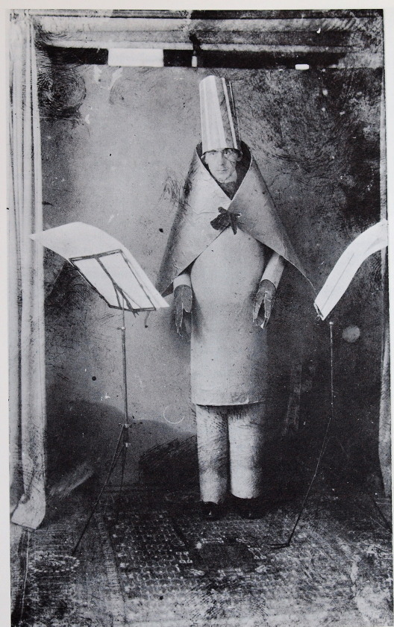
Figure 2 and 3: KARAWANE, 1916, Hugo Ball, Cabaret Voltaire

Performance continued to be developed through Dada and surrealism, in which it saw Ball and Tzara continue to create manifestos and was joined by Richard Huelsenbeck. Richard was a German writer who wrote manifestos in Berlin that reflected ones before that has been devised in Munich and Zurich. He would use taboos as subject to develop peoples understanding of Dada, through works like ‘Dada drummer’ where he responded to the developments of the movements, which again defined an attack on expressionism and the traditional bourgeois in art. Artists surrounded by Dada all wanted to attack the notions of expressionism across German art, with Wedekind, Ball and now Huelsenbeck all pushing to do this. As a result there was a push to create a Dadaist rebellion of the arts in berlin, where manifestos were being published in quick succession and lead to posters being painted all over Berlin. This pushed Dada to reach the height of its notoriety, developing across Europe where manifestos of Dada were applied to performers in Paris and this was later incorporated into surrealism. The push away from expressionism in Germany and the openness of the German art scene was key to opening the gateway for performance.

This continued at the Bauhaus during the 1920s with the pioneering work of Oskar Schlemmmer. Creating links between performance and drawing/painting which began to define that theatre and painting could be complimentary in activities, seeing painting as his theoretical work and performance being his practice. The development of this was a constant preoccupation at the Bauhaus and saw works being created that combined the two forms like tischgesellschaft by Schlemmmer and pictures at an exhibition by Wassily Kandisky. Performance began to be created within the art studios and each of these experiments was created as an element of research into movement and space. As performance became a larger part of the Bauhaus, it was decided to have a theatre, which was created by architect Ahdreas Weininger and saw performances at the Bauhaus get international reputation. This was a result of its support from artists and theorist and the enthusiasm of its participants. Moholy Nagy; a painter and professor at the Bauhaus wrote in one of his essays, Theatre, circus and variety (1924) that “nothing stands in the way of making use of complex APPARATUS such as film, automobile, lift, aeroplane, and other machinery as well as reflecting equipment and so on. Its time to produce a form of stage activity, which will no longer permit the masses to be silent spectators which will…. Allow them to fuse with the actions on the stage” (Goldberg, 1979, p 116-117). Seeing the audience to be a thousand new directors that had modern means of understanding and communication. The Bauhaus artists became much more involved in performance and the creation of ‘live art’, directly translating aesthetics and artists permutations into real space, establishing the Bauhaus in for its development of performance, which spread across many European cities. Unlike Futurists, Dadaists and Surrealist before the Bauhaus had reinforced the importance of performance as a medium in its own right by the 1930’s.

There is a direct time of development where performance art begins to become an active piece of experimentation from fine artists, seeing a fresh wave of expressive and live performance works beginning in America and through theatre. The period between the 1950’s and 1970’s was when artist explorations began to define a new form of practice. Performance began to emerge in the United States after the Second World War, with the inflow of refugees from Europe. It immediately was met with the question of “art is concerned with the HOW and not the WHAT; not with the literal content but with the performance of the factual content. The performance- and how it is done – that is the content of art” (Goldberg, 1979, p121). At this time John Cage and Merce Cunnigham were developing their practice and collaborating at the College, who are recognised today as being key influential artists in the development of modern dance and music. Collaborating with Robert Rauschenberg and seeing artists such as Allan Kaprow, Jim Dine and Jackson MacLow creating an artistic production. Incorporating a key notion of the Black Mountain College, which was of chance, and non-intentional actions that had been absorbed from the DADA and surrealist movements that were before them. Through this collaboration and ethos of the college Live art became the next logical step for the art work; specifically looking at the piece’s environment and assemblage.

The 1950’s also saw Yves Klein, who was emerging to be one of the most well know performance artists and saw his art as a way of life. Not him just painting in a studio, he devoted all his time and art to an action of protest against that artist’s image being limited. Openly realising that he could use the life models in which he paints as the brush to paint with, using these bemused models to paint his prepared canvases, coating them in blue paint. Blue was a colour he linked to the void and became the identifying colour of his work, abandoning the colour pallet traditionally used in a paining, he painted with these human paintbrushes expressively and in front of an audience in a live piece of art. Tragically Klein’s work was cut short with his death caused by a heart attack aged thirty-four. His work was a demonstration to break the traditional institution surrounding art and the tools to create art. Allan Kaprows followed in a similar style of painting in America, saying his paintings were a means to “act out dramas of tin-soldiers, stories sand musical structures that I had once had tried to embody in paintings alone” (Goldberg, 1979, p128). In Allan Kaprows performance piece, 18 Happenings in 6 parts, he invited viewers that he called ‘observers’ to take part stating beforehand ‘you will become a part of the happenings; simultaneously you will experience them’. He divided a gallery into three rooms, which were separated through transparent plastic, and this created a highly immersive environment that interacted with the audience and instructed their participation in the work. This was a sign that the practice of performance art continued to grow across America and the New York art scene. Therefore, leading a major development in the practice that others and myself identify with performance art of today; the artists body.

Back in Europe in the beginning of the 1960’s, the FLUXUS movement was the emergence of a community of artists which was categorised by their shared attitude to the their direction of the arts. Looking to define what art can be and taking a very anti-commercial stance to their work and was key to the development of performance art. Joseph Beuys was also emerging as a contemporary artist in Germany at this time and was heavily involved in the movement; working with the body and stating art needs to be revolutionary and transform its viewer’s lives. FLUXUS constantly wanted to be testing what art can be, emphasising for live and living, echoing Dada from the earlier twentieth century. He utilised very dramatic techniques and props to portray the meanings of his work, including confining himself into small spaces and communicating with dead animals, through mumbling in isolated environments. Therefore, creating works which were highly primitive and transgressive in nature. A piece he performed in 1965, How To Explain Pictures To A Dead Hare, was a performance where he mumbled explanations to his drawings which he carried around the gallery. His actions and methods of communication between himself and his art as well as himself and his audience had a great effect on the FLUXUS movement, with his work and presenting performance works as an art piece. This created the ‘social sculpture’ that could activate influence and mobilise every individual’s creativity. The works of Cage and Cunnigham, Yves Klein, Allan Kaprow and Joseph Bueys pioneered seeing the body being used as a tool for making a work in it across European and American art scenes. Therefore, it is now you can begin to recognise a clear shift towards a more contemporary form of art and performance art as a result, which paved the way for the performance art boom of the 1960’s and 1970’s.

From the late 1960’s there was a discontent in the cultural and social life across Europe; again looking to redefine what art is and why. Seeing conceptual art emerging with a need for the use of space-time and material rather than painted, sculpted or drew representations. French theorist Guy Debord was quoted in the society of the spectacle (1967), that the spectacle of art has become member of all social relations, making authenticity impossible: “all that was once lived directly has become mere representation”. Performance art arises from this perspective as an advocate for the new in the arts as a culture that was completely unmediated. Such openness to new ideas had heavy influence on the new generation of young emerging artists; like Vito Acconci, Yoko Ono, Marina Abramoivic and the Viennese Actionists who are all leading performance artists and influential artists of the next generation today. This shows there has been a development of expressive staging of the body that represents transgression, scarification and decoration of the body and skin. This also cemented the placement of performance art as a medium of the Art practice of today. The performance artists of the 1960’s and the 1970’s really looked to elevate the question of what art can be and the ways in which you can create and present art. Through this, they used transgressive and provocative subjects and methods to provoke a response from viewers, which had been slowly developed by artists in the last century. Using such actionist styles of performance can illustrate the sense of heavy desire and illustrates the naked and raw physicality of the subject, which is often to pushed to its limits. The 1970’s saw artists Gina Pane, Marina Abramovic and Peter Stembera take these ideas to the limits. Exploiting the powerful image of the fragile human body being pushed to its limits and showcasing that fragility and interiority. This is what I wish to focus on and debate within this report.

Performance art: The Social, The Individual and The Object

It has been often difficult to categorise what performance is and the different types that have been developed since it’s founding. Contemporary art has become a practice that has multiple overlapping disciplines within it, performances incorporating painting and sculpture. It also incorporates neighbouring disciplines and practices using theatre, dance and film as well as science, film and politics. Being heavily impacted by the development of technologies over the past fifty years has seen a new branch of knowledge and developments, which has impacted the way we view and develop arts. We need to be able to differentiate between different performance art and performance artists. Posing the question whether the artist is present, the artist/work is a social sculpture or the artist is a living sculpture in them. Author Catherine Wood, describes this, “In the past fifty years, a new lexicon of art-making has emerged that re-casts the roles conventionally ascribed to the participants in the art encounter…. In which to look, explicitly, at the testing of dynamic positions between artist, audience and artwork; a position that proffers concrete new patterns for presenting, paying attention to and participating in art” (Wood, 2018, P24). Performance art is constant in its transgression, in which there are no rules to the progression of performance art and that has been prevalent throughout the history of the movement. Self performance is defined through two major paradigms: looking at the body being presented as an authentic self, showing the real, the vulnerable, the physical and emotional presence.
The most identifiable, is the individual, the performance artist, the performer is represented by an act, which can be experimental, provocative, singular and or transgressive in nature. This is probably the most straightforward method for an audience to understand, as it’s direct, first person and is deliberately exploring a taboo. Historically involving risk, vulnerability, emotion and the human body, putting the performer face to face with the audience around them, and looking to their method of performance as a gateway to understanding more about the body and themselves. This was a method of performance that peaked between the 1950’s to the 1970’s, seeing artists across the world challenge the way in which you could present and confront the physical form. Some of the most famous artists and artworks in the world were created by performance artists, which experimented with the self. Including Yves Klein, Günter Brus and Carolee Shneeman, these artists help develop the notion of performance and the initial engagement of the audience within a performance art piece. If you asked someone to describe a performance art piece this is the most likely of responses identifying works like Yoko Ono’s, Cut piece (1964) or Chris Burden’s, Shoot (1971). This is primarily because they persist in the viewers mind because they seem apparent and socially transgressive that they become memorable, intriguing and explorative.

Art and performance art has changed and developed since the 1960’s, in line with change and upheaval that was being presented. Artists were looking for ways to transform the gallery and they way of seeing and presenting art within them. In the 70’s, Joseph Beuys devised the concept of a ‘social sculpture’, with the notion that if people can be engaged with creative actions, the world could, as a result, be changed. He wanted to blur the boundaries between making art and life, seeing his audience as a mass of creative individuals. He was looking to change the sculpted movement and social behaviours within the gallery space, which wouldn’t normally be associated with such a space. This was a new and exciting way to perceive art, with performance artists until now being seen as an alternative form of art begins, which now was being experimented within institutions traditionally associated with ‘higher’ art. This was presented in Beuys conversational performance, which he presented in the form of a lecture, setting the scene and his vision using chalk and blackboards in, Information in Action (1972). In this lecture, people surrounded him including artists and the audience, whom constantly challenge his concepts that he was presenting which were highly political, debating democracy and authority within an artwork. Since Beuys was using a microphone he had greater projection and a higher power of speech. This idea of directly involving the viewer within the work was taken further by contemporary artists like Tino Shegal. Shegal works conceptually with movement, interaction and speech of different people within a space. This was present in his piece These Associations (2012) where the audience contains people which he calls ‘interpreters’, which move around the gallery space with the visitors where they individually approach and engage with them. He used uncomfortable or problematic narratives, that would make the audience think and feel. After that they would just leave, aiming to present the anonymity and alienation that is becoming ever more prevalent in society. Catherine Wood describes this type of performance to be “Sehgal’s attitude to sculpting live actions is significant because of his insistence that the situations he creates are staged throughout the galleries regular opening hours, giving them presence equivalent to exhibited objects, but disallowing any photographic record” (Wood, 2018, P115). This type of performance is deliberately transgressive in the sense that it calls onto the emotions of the audience, if it’s through debate and confrontation like Joseph Beuys or through invoking anxiety through false stories and communication. These transgressive methods of using taboos to engage audiences to think, is how a performance artist captures the thought, understanding and presence of their audience in a different senses.

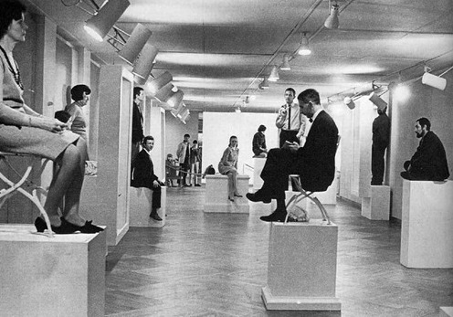
Performance art today can also be interoperated as being a living sculpture, where the audience could be the living part of the artwork. Looking again to redefine what the artwork can be, and actually using the performer within the context of being a sculpture. Performance art has always been defined as looking to remove the object from the space, and to prefer the use of actions in its entirety. During the peak of the more classic styles of performance art, artists represented traditional mediums through performance like sculpture. Artist Pi Lind created a performance work called Living sculptures (1969), which he presented in Stockholm and consisted of himself and others posing as 20 different sculpture types on plinths over a five-day period.
Figure 4: Living Sculptures, 1969, Pi Lind, Stockholm: Moderna Museet.

Artist Hassan Sharif, heavily inspired by the performances writings and critiques of Roselee Goldberg to create a game, which he labelled Body and Squares, to be a social sculpture, creaing a series of actions of repetitions in his head in the heat of the desert. Slowly moving over time, which wouldn’t be noticeable to the average audience. These types of performance works pose a different question to those that are deliberately provocative, and it looks to debate what art can be and presents that to the audience in a very different sense. Seeing a man sat on a plinth as a sculpture in the 1960s would have been something completely comical and different which is what transgressive art attempts to be. I will look at the artists that I have chosen to explore within my case studies to see which represent these different styles of contemporary performance and how that effects their relationship with the audience in terms of provocation and transgression. I will also be discussing how different methods of presenting a taboo to an audience can evoke different reactions and engagement, through the growth of the performance art movement.

Marina Abramovic

Marina Abramovic is one of the most famous performance artists in the world and her work is defined by her ability to explore the themes of morality and question the dynamics of human existence. Her work gained attention in the early 70’s for a series of personal endurance, challenging her own physical endurance limits and the role of the spectator to those performances. She saw the purpose of this to press her own spiritual, cognitive and physical potential and encounter herself. These were often highly charged rituals where you experience her experiment with time to symbols and objects and to her own body. This is highlighted in her Rhythm 5 (1974) performance, involving the five-pointed star, where she sets fire to a star constructed of wood shavings and petrol. Following with a ritual, which she then proceeds to lie within, testing herself and her level of consciousness in a method that was potentially harmful and Avant-Garde. A performance, transgressive in nature, places the audience in the predicament of watching someone openly putting themselves in a potentially fatal situation. Abramoivic described the performance as only partially reaching its full potential due to being interrupted, “I didn’t realise the fire had consumed all of the oxygen when I lay down in the star. I loose consciousness. Because I’m lying, the public does not react. When a flame touches my leg and I still don’t react, two persons from the public enter the star and carry me out. I am confronted with the limits of my body and the performance is interrupted. “(Abramovic, 1998, P62). Abramovic performances were highly personal in terms of developing conscious in understanding of the self, but her audience were often involved within the performance or puts her face to face with the audience. Attempting to understand how the audience within an artwork shapes it and defines what it can be. Her Rhythm series performances were produced during the 70’s where artists had influence from movements before which played into such transgressive developments, combining movements from structuralism, feminism and existentialism.

Abramovic in the late 70’s began creating collaboration works with a fellow performance artist Ulay, where together they produced works that could be seen as transgressive as well as provocative. Work like breathing in breathing out (1977), Imponderabilia (1977) and Relation In Space (1976) all use the naked male and female body as a tool of expression and discussion. Imponderabilia (1977) sees Ulay and Abramovic standing face to face in the entrance to the museum, “the public entering the museum have to pass sideways through the small space between us. Each person passing has to choose which one of us to face” (Abramovic, 1998, P150). The police cut the performance short, which was intended to be 3 hours in duration, to 90 minutes for public indecency. Their intention was to be a human door in a context that would be imponderable; to test people’s sense of imponderability’s in society and human conduct against their aesthetic sensitivity. The audience was forced into the participation in this work, which could have been and probably was deemed to be highly provocative and unsettling, resulting in the police being called. The construct of having two people naked in a doorway is a taboo in itself but it does confront the audience unknowingly with the question as to whether or not to enter, or who to face and if it is right and wrong. Only once someone had passed between them and entered the museum could they then realise that they had been part of a work and had been filmed, as it was displayed back to them through monitors.

Marina Abramovic now aged 72, is still a fully practicing performance artist and her method of creating performance works has adapted in that time. She now describes the future of performance, “is really when the object is removed between the viewer and the performer, so there is just a direct transmission of energy” (Heathfield and Glendinning, 2004, P146-147). In which she does, in her performance in the MoMa, The Artist Is Present (2011), where for three months, eight hours a day Abramovic sat still and silent. Herself being the medium and material, where she sat in front of a table and chair and visitors went to sit before her. The work was comprised of purely presence, with no object or physical material. Abramovic was compared to a living saint within the work as she moved the audience that had experienced it. Her work is exploring the intimacy between artist and audience, a rapport that has been built throughout her career in performances. When looking at the developments of performance art, Marina’s work has adapted over time to form work that engages audiences through nakedness, vulnerability and risk during the 70’s. This has adapted to her work today where here reputation and presence allows her to create performance works based solely on her own presence and her audience’s presence. A concept, that hadn’t been tested or attempted before as an exhibition, which serves as a taboo in itself within the gallery environment. Yes, performance art has allowed the artist to be the work, but never has purely the artist present, with no physical, mental or explicit action before. Marina Abramovic’s work you could say defines the artist presence, within her work. She looks in each performance to reach a new understanding and level of consciousness within herself and also her relationship with the viewer. Her work style adapting into what it is today, which is the understanding of a relationship between energy and presence, between an artist and their audience.

Carolee Schneemann

A developing artist during the 1970’s was Carolee Schneemann, an active feminist and visually experimental artist. Her work was comprised around body, gender, sexuality and narrative, looking to explore the body and taboos around it in relation to social bodies. Her performance body is central to her practice and uses eroticism and sexuality to convey her concepts and discussions of gender politics. Her performance career began in the early sixties where she created a work Meat Joy (1964), which involved participants in the nude dancing and interacting with items like raw fish, sausages, chicken, paint and brushes. Describing it as a “the character of an erotic rite excessive indulgent, a celebration of flesh as a material” (Schneemann and McPherson, 1997, p63). The work was accompanied by an audio voice over and participating audiences were placed as close to the performance as possible, so they could encircle it and resonate within it. She described the close proximity to the audience to having “heightened the sense of communality, transgressing the polarity between performance and audience” (Schneemann and McPherson, 1997, p63). Immediately from this work, Schneemann wanted from an early point within her performance career remove the boundary between performer and viewer. The work is a celebration of flesh, which is quite a morbid celebration considering the flesh was from dead animals, and representing female empowerment. The piece achieved wide recognition for Schneemann, for its openly naked and provocative themes. Nudity was prevalent throughout Schneemann’s work, but one piece could be defined as one of the most provocative pieces of art to date.
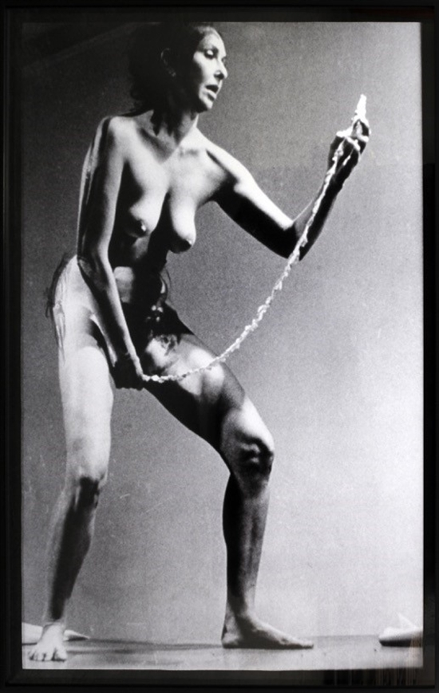

Figure 5: Carolee Schneemann 1977, Interior Scroll, Telluride Film Festival

Interior scroll (1975) is one of her most famous pieces and involved Schneemann performing a ritual, which resulted in her revealing a scroll from her vagina and reading from that scroll. The Vagina was a body part she considered to be wealth of knowledge, a part of the body that provided transformation, ecstasy, and a birth passage but was also conceptually and figuratively a sculpture. She defined this to be the ‘interior knowledge’, which she wanted to represent with revealing the Interior scroll. The work, in concept challenges themes of provocation in discussing the purpose and concept of the female genitals, which would have been part of a much larger feminist discussion that was taking place at the time within society. Interior scroll was devised from feminist text and described the performance to be for women. She began fully dressed within the space, where she climbed onto a table and began to read from her reading, taking the stance of a series of life model poses. At the concluding of the reading she stops the life model poses and begins to extract the scroll, which she reads from piece by piece. The action of revealing the scroll from the vagina and the meaning behind it creates an extremely provocative piece, which the public and the audience reacted to. She described the work herself, as she: “didn’t want to pull a scroll out of my vagina and read it in public, but the culture’s terror of my making overt what it wished to suppress fuelled the image; it was essential to demonstrate this lived action about ‘vulvic space’ against the abstraction of the female body and its loss of meaning” (Schneemann, 1991, p28). The use of provocation within this work was the method of engaging a change in the perception of the feminine and the feminine form. The engagement and understanding of an audience to Schneemann had to evoke some form of provocation or transgression. Interior scroll was performed twice, once in Illinois and the other at the Telluride Film Festival, creating an erotic film series, which to her dismay was called ‘The Erotic Women’. She used this title and the performance of interior scroll to try and redefine the stereotypes associated with the erotic women within film culture. “Perhaps these films will redefine ‘The Erotic Women’; or to the contrary the films will be found to be anti-erotic, sub-erotic, non-erotic. Perhaps this ‘erotic women’ will be seen as primitive, devouring, insatiable, clinical, obscene; or forthright, courageous, integral” (Schneemann and McPherson, 1997, p237). These erotic and provocative works were met with a variety of empowerment encouragement but also with heavy criticism during the 70’s, from the male and the female. Resenting the eroticism shown in the work or describing it as a play into the male fantasy and displaced the privacy of the female form. Schneemann was met by a constant battle against the whole concept of expressing pleasure and sexuality. As the feminism evolved within society and became a main stream adapted concept, Schneemann’s work has been applauded and seminal for the developments of the new waves of feminism and the way in which we observe the female body.

During her career she used animals as a medium of exploration, and she used costumed and live animals within her performances, using apes, cats, dogs and snakes. The Queen’s Dog (1965) was a performance between Schneemann and director Ken Dewey, who had experience in merging performance with the environment and the spectators of performance works. The performance consisted of the involvement of three women, a director and this dog costume character, which was meant to in its actions come across as direct and intimidating. The performance saw the director dragging women out onto the stage and covering them in foam and then moving onto the next. Whilst doing this he howled and growled to symbolise when he was moving to the next. The females, which had been relatively motionless throughout, had foam applied to all areas of their bodies, which they then used to rub against each other. The third woman resisted the foaming which resulted in the woman pushing the director to the ground while growling and grunting, and this marked the end of the performance. During the foaming of the females, a man dressed as a dog would come over and prolifically lick them, shake his tall and receive pats. Schneemann describes the dog as “the wandering, free libido of a robust, typically masculine” (Schneemann and McPherson, 1997, p90). This performance was again posing tough questions around bodily experiences and setting her scene of challenging and questioning from the position of powerful and embodied women. The work that Schneemann presented during the 1960’s-70’s looked to provocatively dramatize the artwork to turning the interior to the exterior, using the body, sex and skin to present this. Works like interior scroll were received as being provocative and transgressive in nature and presented a clear question and thought within the viewer. Which Schneemann believed to be essential to change the world’s opinion and the world perception of the female within an artwork.

Tanya Burguera

Tanya Burguera is a Cuban performance artist and installation based artist, her artwork takes an extremely activist stance and as a result she has been arrested for it. Her work is subjected around herself and in her earlier works like The Burden of Guilt (1985-86), which was inspired by political activism and an inspiration to her Ana Mindenda. The performance was based upon a legend in which there was a large suicide of indigenous Cubans, resisting the colonial Spanish. This involved Burguera mixing soil and salt water and drinking it continuously for 45 minutes, she did this with a lamb carcass draped around her neckline. She was aiming to be a signifier for oppression and the denial of Cuban freedom. This act of eating dirt and heavily interacting with it is massively animalistic and heavily transgressive, the work isn’t openly provocative in nature but her intentions within her work wish to discuss that which is immoral through reacting historical moments.

This challenge of politics remains throughout the series of her work including her 2009 performance called Self-sabotage (2009), in which she performed in the form of a lecture playing Russian roulette with herself and a 9mm firearm, really attempting to take the staging of the body to its limits. Bueguera placed herself at a table reading from a spoken word on her reflections of the function of politics within art and political art to date. Twice during the spoken word she picks up the gun and places a bullet within, and turns the drum. Unknowingly and firmly puling the trigger each time and then answered a series of questions after the performance was finished. This performance was described as “commenting on the function of the artists as a catalyst of social change, as well as being concerned with the idea of sacrifice: of oneself in the interest of ones ethical values as an artist” (Wood, 2018, p79). Using her art as a tool of self-aggression and taking a political stand, this is ultimately very provocative in nature and that was the ultimate purpose of Burguera’s work; to shock and to change. Cuban politics, in which she had a strong opinion in, was a result of her childhood and her father, who was a minister and diplomat for Fidel Castro’s Government. Due to her father’s job, they travelled until Burguera became tired of the process and politics choosing to rebel and returning to Havana.
Figure 6: Tania Burguera, Self-Sabotage, 2009, Jeu de Paume , Paris

One of Burguera’s more recent works was at Tate Modern in 2008 and looked to discuss the themes of censorship and government oppression within the piece. Tatlin’s whisper 2008 sees mounted policeman separate and control the audience of the exhibition. Wanting to represent the control and manipulation of those in power over the public, in works like this Burguera is actively looking to create political structures and scenarios and then attempting to attack and get the audience to question them, trying to create a sense of empathy within the viewers of the pieces in seeing future similar situations because them themselves have experienced it. Burguera has a heavy history with the police and detainment for her anarchistic behaviour in Cuba and this is one of the main calling points to her fame provocation in the work. When asking to describe her work within a few sentences Burguera describes her practice as ‘behaviour art’ and her work is a constant test of patriarchal change, which often results in her arrest or detainment proving her right in the fact that nothing has changed. In a question and answer session with the Los Angeles Times, she describes her work in a nutshell that defines her works transgressive nature, saying, “For me, this is "Arte de Conducta" — Behavior Art — and it's a piece that is decided not by the artist but by a political condition, it was like a test to see how ready everyone was to create a new behavioural dynamic. Right now, people have an on/off button that they turn on and off when something like this happens. I wanted to change that reaction. I wanted to prove that people could talk peacefully, that they could be tolerant of different opinions and that the police would behave differently” (Carolina A. Miranda, ‘Q&A, 2015). This is in my opinion, a very important quote, that showcases that performance artists like Burguera use provocative performance as a method for change. Provocation is activism and activism is art to her, if the artwork is still provocative and not accepted then there has been no change. This is something that we can argue through a lot of provocative performance art works. Carolee Schneemans pieces like Interior Scroll looks to inspire change in the view of the female and the feminine, whereas Burguera looks to inspire political change and explore the notions of power within society. Provocation is a tool for change because it engages an audience to think and remember, which can be difficult to portray through any other art movement.

Despina Zacharopoulou

When looking at the development of performance artists and their engagement with an audience, we need to look at performance art today. Performance art today has become an integral part of gallery life and culture, which encompasses a broad new understanding, theory, and analysis of live art. Roselee Goldberg has characterised this as “as significant visual art form, emphasising, among other facets: the ways in which performance allows for the layering of ideas and commentary, to reflect the multitasking ethos of our times; how it incorporates fast-paced technologies that are available to most; and its potential for reaching ever broader audiences as a result of active engagements” (Goldberg, 2018, p7). There is a clear demonstration to the change in which performance is viewed by an audience within the world of art; one which is now much more egalitarian and inclusive. Therefore, the very nature in which a performance may be seen to be provocative and or transgressive has changed or in some cases disappeared. Despina Zarcharopoulou is a new emerging durational performer in the art community and has studied at the MAI (Marina Abramovic Institute) and the Royal College of Art. Her work looks to explore performance and redefine it as a method of exposing surface and truth, where her stage of exposure can be a hiding place, an event of beauty and can generate image and thought. Her practice is different because she uses durational performances that can last between a few hours to a few months, to discuss ‘alterity’. This looks at being different and going against the notion of ‘sameness’, its defined as meaning the other of two in Latin. She uses this notion of ‘alterity’; to create experimental situations that are live performances that involve interactions with her audiences, believing heavily has performance art as a method of communication and understanding. She looks to find herself within her performance and discover more about her and her audience. Seeing the exhaustion and tests of a physical durational performance within herself and sometimes her audience to open up mental spaces that we couldn’t access in any other context.
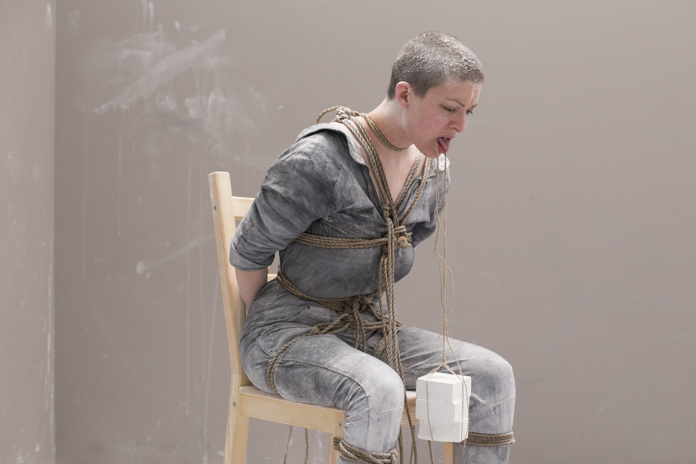
Figure 7: Corner Time, 2016, Despina Zarcharopoulou,, Athens: Benaki Museum.

There are two of her performances in particular where you can really interpret a development of a new type of performance art emerging. A movement much calmer, which contains much less provocation in comparison to the works of Abramovic and Schneemann during the 1970’s. This is a performance practice that takes a much softer approach to the work but can still be equally as transgressive in nature. The performance work Corner Time (2016) was a durational performance that lasted 8 hours a day, for 39 days. In total the performance was 324 hours long, wanting to explore the mental headspace of herself and her audience, through a series of controlled exchanges where the audience is enclosed in the performance space with the performer. Where Zarcharopoulou looks to explore here own personal restraints, discipline and mediation with the added interactions of the audience and their reactions to her work. She described the audience’s responses to the work as “At one point I reached my limits but the energy I take from visitors to the project quickly manage to transform this negative emotion into something positive” (Corner Time, 2016). The audience engagement , which you can see within the documentary of the work, takes an active role in encouraging and caring for the performer. Zarcharopoulou uses chalk and ropes to tie herself together and constrict the body in a clearly tortious manor which the audience engage with emotionally. Human nature takes over as the audience creates an emotional connection to her, with the act of caring through stroking, consoling and becoming emotional. I find this piece uniquely transgressive because its gentle approach to performance really highlights the development and inclusiveness of the performance movement within art. The act of a human actively self-harming Is something that as a society we find massively despondent and that as a piece of work is always going actively engage an audience emotionally.

Zarcharopoulou performance practice in other cases has wanted to invoke thought, change and response, through being direct and provocative. The piece We The Enemy Manifesto 2017 was performed at the London Frieze festival. It was part of a series of performances that wanted to act like a set of interventions inspired by the queer movement of the 1960’s. She was invited to create a performance around a manifesto that highlighted the oppression experienced by people within the LGBTQ community. Zarcharopoulou stands above the audience and chooses to conduct a piece of spoken word; calling out the names stereotyped with people within that community “the lesbians, the cock suckers, the sword swallowers”. This continued when she took the stance of a confrontational character, staring at her audience, walking over to them in an aggressive manner and staring at one individual directly. This performance is vastly different to the performance discussed prior. The change between an internally and personally emotional works to an openly aggressive outgoing piece. Both engage an audience but for different reasoning, both are emotional but for different emotions. This performance looks to actively promote and force change similar to the work in the 90’s by Tania Burguera and Carolee Schneemann. It’s taking an active look at the current society and rejecting it, using language and actions that are vulgar and coarse, in an attempt to develop an understanding of why that is wrong. Confronting the problem being performed with a provocative viewpoint.

Conclusion

Performance art can be traced back to the Russian Avant-Garde and Futurism, the anarchist style of art and the need for a new progression within it kick-started performance. Seeing experimental artists flourish through the Cabaret Voltaire and backing Manifestos, which allowed for artists to experiment with this new, radical Avant-Garde form of art. Performance art had to be transgressive and provocative in its earlier stages to be rebellious and anarchistic against the traditional modernistic styles of art. The DADA movement pioneered this with artists wanting to create work that questioned the very purpose of art and change this modernist perception. This thesis has shown that performance artists in its emerging years, in particular the 60’s and 70’s, where artists had to use transgressive and provocative concepts for audiences to pay attention and take notice. Work by Carolee Schneemann and Tania Burguera conceptually wanted to discuss the perception of the female form and the inequality within society; two areas which were rife at the time. Therefore, provocation and transgression are a means of engagement for purpose in this instance, the artist uses such techniques to get their art noticed and more importantly to get the viewer to think. A transgressive piece of art represents something to society that is apparent or unrecognised and societal, and with intrigue and question being part of human nature; this in turn allows the performer to capture the performance in a raw and honest way. I find this especially apparent in Zarcharopoulou performance Corner time; this engagement encourages the performer but also reassures them that their work is connecting with the audience emotionally and conceptually.

I can now highlight that there is a difference between a work being provocative and a work being transgressive, a work can be both but they do have different characteristics to that performance. Corner time by Despina Zacharopoulou cannot be categorised the same as one of Tania Burguera’s pieces, the method to creating an audiences engagement is completely different and approached in very different ways. Burguera is provocative in the sense that she is toying with life and death in her work, to openly challenge patriarchal traditions and raise awareness and opinions on oppression. Burguera’s work has to be provocative because she wants change in an environment that is hostile and anti freedom of speech. Therefore, provocation is the best method to promote and inspire to her, which she calls ‘behavioural art’. Despina Zacharopoulou who’s works are very personally challenging, has taken heavy influence from Marina Abramovic, in which she engages an audience not through provoking reaction, but through directly provocative roots like Schneemann with the female form, Burguera with politics anarchy or Chris Buren with body mutilation. Engagement through expressing feelings and emotion within the performer themselves; actively is testing her individual boundaries pushing through pain and tension, to a greater level of space and consciousness. The audience can connect to this; because it’s human nature is quite a taboo to stand by and watch a person in pain or in a situation. This transgressive means captures the audience, in a way which isn’t forced, or something that could have been deemed as being offensive.

The way in which performance has developed has allowed for a variety of different ways for an artist to portray the work, which can be through performativity actions within the artwork, manipulating the audience through participating in it, or the artist themselves becoming the artwork in the form of a social sculpture. An artist becoming the artwork was a theme that has been very Avant-garde but for an artist to become the sculpture also something massively transgressive. How can a person being sat on a plinth be considered a piece of art, how can an artist lying on the ground be art? These were the questions that were being raised and represented through the 60’s and 70’s. With the backing of theorists like Rosalind Krauss who completely opposed modernism within the arts, creating the post medium condition. Through this performance thesis I have discussed a variety of artists that have showcased the broadness that performance has come to present. Seeing that performance artists use both provocative and transgressive taboos to convey their concepts as an artist to the audience for change or to test their personal boundaries in which the audience can watch, comment upon and participate in. Using such taboos has been fundamental to the ethos of performance art from its anarchistic origins against modernism, to the debate of feminism, politics and presence to what it is today. Marina Abramovic is a firm example of a performance artist that has adapted and changed her performance style through her career, from using provocative methods of practice in her earlier works in her Rhythm series to her more contemporary practice, which is more transgressive in nature like The Artist is present. Adapting her performance style to keep the discussion of what performance art can be and the methods in which a relationship can be formed between an artist and the audience within a performance work.

Bibliography:

Readings:

- Abramovic, M. (1998). Artist Body. Milan: Edizioni Charta.
(Abramovic, 1998)

- Fowler, F. (2012). Concise oxford dictionary of current english. [Place of publication not identified]: Rarebooksclub Com.
(Fowler, 2012)

- Goldberg, R. (2018). Performance now. Thames & Hudson.
(Goldberg, 2018)

- Goldberg, R. and Anderson, L. (2004). Performance. Paris: Thames & Hudson.
(Goldberg and Anderson, 2004)

- Guy Debord, the society of the spectacle, tans. Donald Nicholson-Smith, New York 2006, p.12.

- Heathfield, A. and Glendinning, H. (2004). LIVE ART AND PERFORMANCE. Tate Publishing.
(Heathfield and Glendinning, 2004)

- Performance Art Magazine, No. 1 (complete issue). (1988). Performance Art Magazine, 53(53), pp.1-47.
(Performance Art Magazine, No. 1 (complete issue), 1988)

- Performance Art Magazine, No. 1 (complete issue). (1980). Performance Art Magazine, 1(7), pp.1-47.
(Performance Art Magazine, No. 1 (complete issue), 1980)

- Performance Art Magazine, No. 1 (complete issue). (1990). Performance Art Magazine, 1(59n), pp.1-47.
(Performance Art Magazine, No. 1 (complete issue), 1990)

- RoseLee Goldberg, Performance Art: From Futurism to the Present, London 1979 (third edition, 2011), pp12, 32.
(Goldberg, 1979)
- Schneemann, C. and McPherson, B. (1997). More than meat joy. Kingston, N.Y.: McPherson & Co.
(Schneemann and McPherson, 1997)

- Wood, C. (2018). Performance in Contemporary Art. 1st ed. London: Tate Publishing.
(Wood, 2018)

Artist Interviews:

- Carolina A. Miranda, ‘Q&A: Tania Bruguera on Her Art, Her Detentions and What Happens Next’, Los Angeles Times, 10 January
2015, http://www.latimes.com/entertainment/arts/miranda/la-et-cam-cuban-artist-tania-bruguera-her-arrests-and-why-she-remains-in-cuba-20150107-column.html#page=1, accessed 30 April 2019

- Schneemann, C. (1991). The Obscene Body/Politic. Art Journal, 50(4), p.28.
(Schneemann, 1991).

Documentary films:

- Corner Time. (2016). [video] Directed by L. Botasi. Benaki Museum, Athens, Greece: Dimitris Hatzivogiatzis.
(Corner Time, 2016)

Artworks cited:

- Abramovic, M. (1974). Rhythm 5. [Performance] Belgrade: Studenski Kulturni Centar.

- Abramovic, M. (1977). Imponderabilia. [Performance] Bologna: Galleria Communale d'Arte Moderna.

- Abramovic, M. (2011). The Artist is Present. [Performance] New York: MoMa, Museum of Modern Art.

- Abramovic, M. (1977). Breathing in Breathing out. [Performance] Belgrade: Studenski Kulturni Centar.

- Abramovic, M. (2019). Rhythm 0. [Performance] Naples: Studio Mora.

- Acconici, V. (1972). Seedbed. [Performance] New York: Sonnabend Gallery.

- Ball, H. (1916). KARAWANE. [Performance] Zurich: Cabaret Voltaire.

- Bruguera, T. (2008). Tatlin's Whisper. [2008] London: Tate Modern.

- Bruguera, T. (2009). Self-Sabotage. [Performance] Paris: Jeu de Paume.

- Burguera, T. (1999). The Burden of Guilt. [Performance].

- Beuys, J. (1965). How To Explain Pictures To A Dead Hare. [Performance] Düsseldorf: Galerie Schmela.

- Beuys, J. (1972). Information in Action. [Performance Lecture] London: Whitechapel Gallery.

- Burden, C. (1974). One Shoot. [Performance] California: F Space, Santa Ana.

- Debord, G. (1967). The society of the spectacle. London: Verso.

- Hindemith, P. (1907). Mörder, Hoffnung der Frauen. [Opera] Stuttgart: Staatstheater.

- Huelsenbeck, R. and Kleinschmidt, H. (1991). Memoirs of a Dada drummer. Berkeley: University of California Press.

- Kaprow, A. (2019). 18 Happenings in 6 Parts. [Performance] New York: Reuben Gallery.

- Lind, P. (2067). Living Sculptures. [Social Sculpture] Stockholm: Moderna Museet.

- Ono, Y. (1964). Cut Piece. [Performance] Kyoto.

- Schneemann, C. (1964). Meat Joy. [Performance] Paris: Festival de La Libre Expression.

- Schneemann, C. (1965). The Queen's Dog. [Performance] New York: Judson Dance Theater.

- Schneemann, C. (1977). Interior Scroll. [Performance] Telluride, Colorado: Telluride Film Festival.

- Schlemmer, O. (1923). Tischgesellschaft. [Painting, Oil on Canvas].

- Shegal, T. (2012). These Associations. [Performance] London: Tate Modern.

- Sharif, H. (1983). Body and Squares. [Performance] Satwa, Dubai: Artists Studio.

- Zarcharopoulou, D. (2016). Corner Time. [Performance] Athens: Benaki Museum.

- Zarcharopoulou, D. (2017). "We the Enemy" Manifesto. [Performance] London: London Frieze Art Fair 2017.

Images cited:

- Figure 1:
Abramovic, M. (2011). Artist Is Present. [image] Available at: https://news.artnet.com/art-world/marina-abramovic-ulay-relationship-interview-1045136 [Accessed 6 May 2019]

- Figure 2
Ball, H. (1916). KARAWANE. [image] Available at: https://www.google.com/search?q=hugo+ball+karawane&source=lnms&tbm=isch&sa=X&ved=0ahUKEwiPgLP4vP_hAhWrRRUIHeCyDr4Q_AUIDygC&biw=1280&bih=726#imgrc=LNsfDtwkEWr_mM: [Accessed 3 May 2019].

- Figure 3:
Ball, H. (1916). KARAWANE. [image] Available at: http://blog.owlperformanceart.eu/?p=542 [Accessed 3 May 2019].

- Figure 4:
Lind, P. (1967). Living sculpture. [image] Available at: https://theartstack.com/artist/pi-lind/living-sculptures [Accessed 4 May 2019].

- Figure 5:
Schneemann, C. (1975). Interior Scroll. [image] Available at: https://www.artnet.com/auctions/artists/carolee-schneemann/interior-scroll-2 [Accessed 2 May 2019].

- Figure 6:
Burguera, T. (2009). Self Sabotage. [image] Available at: https://www.taniabruguera.com/cms/111-0-Self-sabotage.htm [Accessed 6 May 2019].

- Figure 7
Zacharopoulou, D. (2016). Corner time. [image] Available at: https://mai.art/durational-performances/2016/3/1/despina-zacharopoulou [Accessed 2 May 2019].

